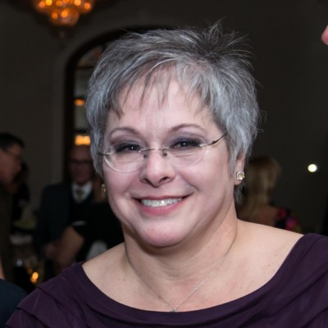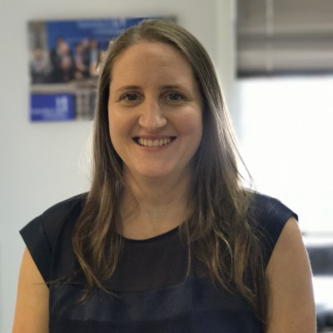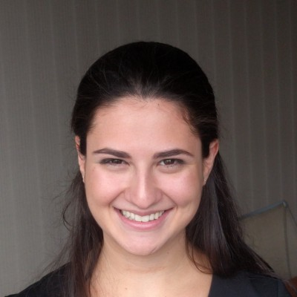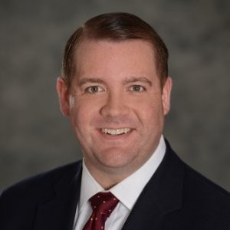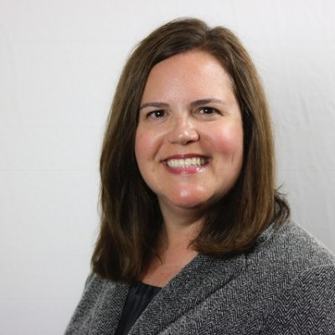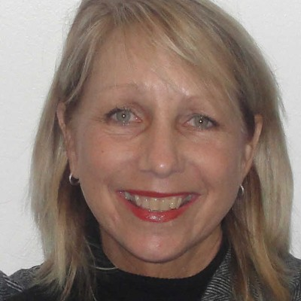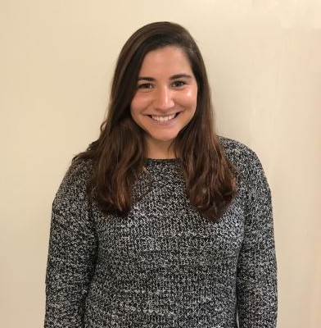 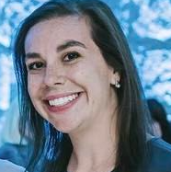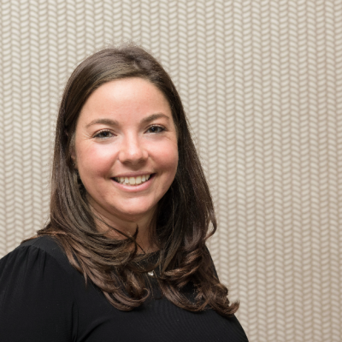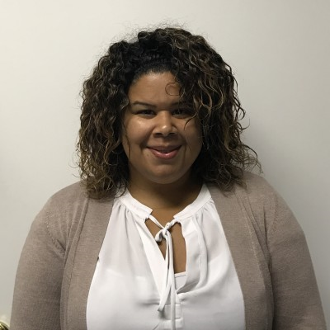 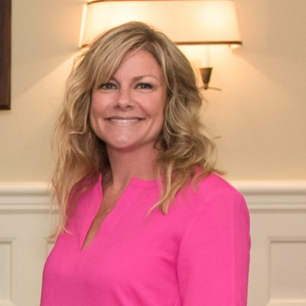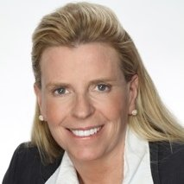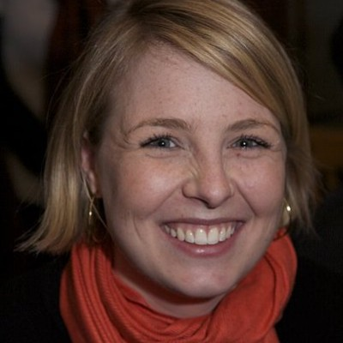

Bill Kelly Rachel Kramer Sallie Lynch Lisa Oosterom

Chief of Philanthropy Development Manager Senior Program and Chief Financial Officer

Development Consultant

Deanna Brugger Karen Burris Angela Choi Lisa Jettmar

Program Coordinator Military Initiative Outreach Officer Program Manager Chief Operations Officer

Bill Kelly Rachel Kramer Sallie Lynch Lisa Oosterom

Chief of Philanthropy Development Manager Senior Program & Chief Financial Officer

Development Consultant

Rosemary Peralta Emily Racanelli Marin Schloss Jordyn Scorpio Database Manager Marketing and Outreach Coordinator Associate Director of Senior Program Manager

Development and Events

Terry Sears Sara Wingerath-Schlanger Amy Wright Liz Zirkle Executive Director Senior Director of Mentoring Corporate Relations Officer Director of Military Initiative